Finance Self-Learning (Sion)

# Money Market vs Capital Market

The market for long-term securities, including the stock market and the bond market.

**The money market** is the trade in short-term debt. It is a constant flow of cash between governments, corporations, banks, and financial institutions, borrowing and lending for a term as short as overnight and no longer than a year.

**The capital market** encompasses the trade in both stocks and bonds. These are long-term assets bought by financial institutions, professional brokers, and individual investors.

Together, the money market and the capital market comprise a large portion of what is known as the **financial market.**

## The Money Market

The money market is a good place for individuals, banks, other companies, and governments to park cash for a short period of time, usually one year or less. It exists so that businesses and governments that need cash to operate can get it quickly at a reasonable cost, and so that businesses that have more cash than they need can put it to use.

**KEY TAKEAWAYS**

* The money market is a short-term lending system. Borrowers tap it for the cash they need to operate from day to day. Lenders use it to put spare cash to work.
* The capital market is geared toward long-term investing. Companies issue stocks and bonds to raise money to grow their businesses. Investors buy them to share in that growth.
* The money market is less risky than the capital market while the capital market is potentially more rewarding.
* The returns are modest but the risks are low. The instruments used in the money markets include deposits, collateral loans, acceptances, and bills of exchange. Institutions operating in the money markets include the Federal Reserve, commercial banks, and acceptance houses.

When a company or government issues short-term debt, it's usually to cover routine operating expenses or supply working capital, not for capital improvements or large-scale projects.

**About Liquidity**

The money market plays a key role in ensuring that banks, other companies, and governments maintain the appropriate level of liquidity on a daily basis, without falling short and needing a more expensive loan and without hoarding excess cash that isn't earning interest.

Individual investors may use the money markets to invest their savings in a safe and accessible place. Many choices are available, including mutual funds that focus on state money market funds, municipal funds, and U.S. Treasury funds. Many of the government funds are tax-free. A money-market fund also can be opened at most banks.

### Following are the features of money market:

1. Transaction volume in the money market is usually large since it is a wholesale market.
2. There are various organizations and entities such as banks, mutual funds and so on who benefit from the money market and are active participants
3. Money market is all about professional terms and pure competition. The borrower here looks for liquid funds, while the lender is looking for a quick return.

Following are the **popular money market instruments** – Certificate of Deposit (CD), Commercial papers, Swaps, Government Treasury certificate, Repo, Backup line of Credit, Credit Enhancements, Bankers’ Acceptance, Repurchase Agreements and more.

## The Capital Market

It is a marketplace where both buyers and sellers come together to buy, sell and trade long-term financial securities such as bonds, stocks and so on. Both institutional and individual investors participate in the capital market.

The overriding goal of the companies institutions that enter into the capital markets is to raise money for their long-term purposes, which usually come down to expanding their businesses and increasing their revenues. They do this by issuing stock shares and by selling corporate bonds.

Following are the functions of the capital market:

1. Convert saving into long-term investments.
2. Enable smooth trading of the securities by retail investors.
3. Bring down the cost of transaction and information cost.
4. Helps in easy valuation of instruments such as shares, bonds and debentures.
5. Productive assets get a wide range of ownership.
6. Competitive price mechanism in the secondary market helps in better allocation of the capital.

### Primary and Secondary

The capital market is roughly divided into a primary market and a secondary market. A company that issues a round of stock or a new bond places it in **the primary market** for sale directly to investors or institutions. **If and when those buyers decide to sell their shares or bonds, they do so on the secondary market**. The original issuer of those stocks or bonds does not immediately benefit from their resale, although companies certainly have an interest in the price of their stock shares rising over time.

The capital market is by nature riskier than the money market and has greater potential gains and losses.

## Money Market vs Capital Market – Differences

Following are the differences between money market vs capital market:

**Borrowing Term**

Lending and borrowing in the money market is for the short-term. In the capital market, investors lend and borrow securities for medium term to long-term.

**Participants**

Usual participants in the money market are central banks, commercial banks, mutual funds, financial institutions and chit funds. Capital market, on the other hand, involves stock brokers, retail investors, mutual funds, underwriters, insurance companies and stock exchanges

**Instruments**

Popular instruments in the money market are commercial papers, T-bills, call money, promissory notes and so on. Capital markets typically deal in bonds, debentures, preference shares and so on.

**Structure**

Capital markets are more formal than the money market. Compared to capital markets, money markets are more informal. Also, capital markets are more organized than the money market.

**Classification**

There are two types of capital markets – Primary Market and Secondary Market. There is no such classification in the money market.

**Liquidity**

Since money market deals with short-term instruments, it is more liquid. Capital market deals in medium to long-term time frame, thus liquidity is less.

**Risk Factor**

Money market usually involves less risk as the market is liquid and funds are for the short-term. Due to long-term maturity and comparatively less liquidity, the risk in the capital market is more.

**Purpose**

It helps borrowers to meet their short-term funding requirements. Due to its long-term nature, the capital market works more towards stabilizing the economy by mobilizing the savings.

**Returns**

Since the time duration is short and the risk is less, returns in the money market are also less. Return in the capital market is more as the investment is for more duration.

**Relevance to Economy**

Money market helps to boost liquidity in an economy. Capital market, on the other hand, converts savings into productive investments.

**Maturity Period**

Money market instruments have a max maturity period of one year. In the capital market, there is no specified maturity period for the instruments, but it is always more than a year.

**Relation with Country’s Central Bank**

Money market and Central bank work closely with each other. Central bank’s policies influence the working of the capital markets, but there is no direct relation between the two.

# Derivatives

A **derivative** is a financial security with a value that is reliant upon or derived from, an underlying asset or group of assets—a benchmark. The derivative itself is a contract between two or more parties, and the derivative derives its price from fluctuations in the underlying asset.

The most common underlying assets for derivatives are stocks, bonds, commodities, currencies, interest rates, and market indexes. These assets are commonly purchased through brokerages.

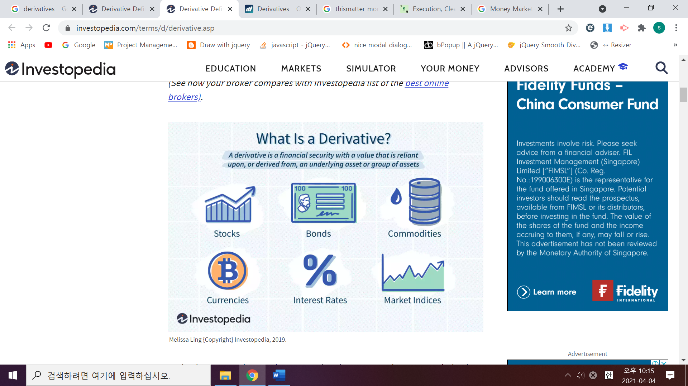

Derivatives can trade **over-the-counter (OTC)** or on an **exchange**. OTC derivatives constitute a greater proportion of the derivatives market. OTC-traded derivatives, generally have a greater possibility of counterparty risk. **Counterparty risk** is the danger that **one of the parties involved in the transaction might default.** These parties trade between two private parties and are unregulated.

Conversely, derivatives that are **exchange-traded** are standardized and more heavily regulated.

**KEY TAKEAWAYS**

* A derivative is a contract between two or more parties whose value is based on an agreed-upon underlying financial asset, index, or security.
* Futures contracts, forward contracts, options, swaps, and warrants are commonly used derivatives.
* Derivatives can be used to either mitigate risk (hedging) or assume risk with the expectation of commensurate reward (speculation).

**The Basics of a Derivative**

Derivatives can be used to hedge a position, speculate on the directional movement of an underlying asset, or give leverage to holdings. Their value comes from the fluctuations of the values of the underlying asset.

Originally, derivatives were used to ensure balanced exchange rates for goods traded internationally. With the differing values of national currencies, international traders needed a system to account for differences. Today, derivatives are based upon a wide variety of transactions and have many more uses. There are even derivatives based on weather data, such as the amount of rain or the number of sunny days in a region.

For example, imagine a European investor, **whose investment accounts are all denominated in euros (EUR).** **This investor purchases shares of a U.S. company through a U.S. exchange using U.S. dollars (USD).** Now the investor is exposed to exchange-rate risk while holding that stock. **Exchange-rate risk the threat that the value of the euro will increase in relation to the USD**. If the value of the euro rises, any profits the investor realizes upon selling the stock become less valuable when they are converted into euros.

To hedge this risk, the investor could purchase a currency derivative to lock in a specific exchange rate. Derivatives that could be used to hedge this kind of risk include currency futures and currency swaps.

A speculator who expects the euro to appreciate compared to the dollar could profit by using a derivative that rises in value with the euro. When using derivatives to speculate on the price movement of an underlying asset, the investor does not need to have a holding or portfolio presence in the underlying asset.

KEY TAKEAWAYS

* Derivatives are securities that derive their value from an underlying asset or benchmark.
* Common derivatives include futures contracts, forwards, options, and swaps.
* Most derivatives are not traded on exchanges and are used by institutions to hedge risk or speculate on price changes in the underlying asset.
* Exchange-traded derivatives like futures or stock options are standardized and eliminate or reduce many of the risks of over-the-counter derivatives
* Derivatives are usually leveraged instruments, which increases their potential risks and rewards.

## Common Forms of Derivatives

There are many different types of derivatives that can be used for risk management, for speculation, and to leverage a position. Derivatives is a growing marketplace and offer products to fit nearly any need or risk tolerance.

### Futures (선물)

**Futures contracts**—also known simply as **futures**—are an agreement between two parties for the purchase and delivery of an asset at an agreed upon price at a future date. **Futures trade on an exchange**, and the contracts are standardized. Traders will use a futures contract to hedge their risk or speculate on the price of an underlying asset. The parties involved in the futures transaction are obligated to fulfil a commitment to buy or sell the underlying asset.

For example, say that Nov. 6, 2019, Company-A buys a futures contract for oil at a price of $62.22 per barrel that expires Dec. 19, 2019. The company does this because it needs oil in December and is concerned that the price will rise before the company needs to buy. Buying an oil futures contract hedges the company's risk because the seller on the other side of the contract is obligated to deliver oil to Company-A for $62.22 per barrel once the contract has expired. Assume oil prices rise to $80 per barrel by Dec. 19, 2019. Company-A can accept delivery of the oil from the seller of the futures contract, but if it no longer needs the oil, it can also sell the contract before expiration and keep the profits.

In this example, it is possible that both the futures buyer and seller were hedging risk. Company-A needed oil in the future and wanted to offset the risk that the price may rise in December with a long position in an oil futures contract. The seller could be an oil company that was concerned about falling oil prices and wanted to eliminate that risk by selling or "shorting" a futures contract that fixed the price it would get in December.

It is also possible that the seller or buyer—or both—of the oil futures parties were speculators with the opposite opinion about the direction of December oil. If the parties involved in the futures contract were speculators, it is unlikely that either of them would want to make arrangements for delivery of several barrels of crude oil. Speculators can end their obligation to purchase or deliver the underlying commodity by closing—unwinding—their contract before expiration with an offsetting contract.

For example, the futures contract for West Texas Intermediate (WTI) oil trades on the CME represents 1,000 barrels of oil. If the price of oil rose from $62.22 to $80 per barrel, the trader with the long position—the buyer—in the futures contract would have profited $17,780 [($80 - $62.22) X 1,000 = $17,780]. The trader with the short position—the seller—in the contract would have a loss of $17,780.

Not all futures contracts are settled at expiration by delivering the underlying asset. **Many derivatives are cash-settled,** which means that the gain or loss in the trade is simply an accounting cash flow to the trader's brokerage account. Futures contracts that are cash settled include many interest rate futures, stock index futures, and more unusual instruments like volatility futures or weather futures.

### Forwards (선도 계약)

**Forward contracts**—known simply as **forwards**—are **similar to futures, but do not trade on an exchange, only over-the-counter**. When a forward contract is created, the buyer and seller may have customized the terms, size and settlement process for the derivative. As OTC products, forward contracts carry a **greater degree of counterparty risk** for both buyers and sellers.

Counterparty risks are a kind of credit risk in that the buyer or seller may not be able to live up to the obligations outlined in the contract. If one party of the contract becomes insolvent, the other party may have no recourse and could lose the value of its position. Once created, the parties in a forward contract can offset their position with other counterparties, which can increase the potential for counterparty risks as more traders become involved in the same contract.

### Swaps (스왑)

**Swaps** are another common type of derivative, **often used to exchange one kind of cash flow with another**. For example, a trader might use an **interest rate swap** to switch from a variable interest rate loan to a fixed interest rate loan, or vice versa.

Imagine that Company XYZ has borrowed $1,000,000 and pays a variable rate of interest on the loan that is currently 6%. XYZ may be concerned about rising interest rates that will increase the costs of this loan or encounter a lender that is reluctant to extend more credit while the company has this variable rate risk.

Assume that XYZ creates a swap with Company QRS, which is willing to exchange the payments owed on the variable rate loan for the payments owed on a fixed rate loan of 7%. That means that XYZ will pay 7% to QRS on its $1,000,000 principal, and QRS will pay XYZ 6% interest on the same principal. At the beginning of the swap, XYZ will just pay QRS the 1% difference between the two swap rates.

If interest rates fall so that the variable rate on the original loan is now 5%, Company XYZ will have to pay Company QRS the 2% difference on the loan. If interest rates rise to 8%, then QRS would have to pay XYZ the 1% difference between the two swap rates. Regardless of how interest rates change, the swap has achieved XYZ's original objective of turning a variable rate loan into a fixed rate loan.

Swaps can also be constructed to exchange currency exchange rate risk or the risk of default on a loan or cash flows from other business activities. Swaps related to the cash flows and potential defaults of mortgage bonds are an extremely popular kind of derivative—a bit too popular. In the past. It was the counterparty risk of swaps like this that eventually spiralled into the credit crisis of 2008.

### Options (옵션)

An **options** contract is **similar to a futures contract** in that it is an agreement between two parties to buy or sell an asset at a predetermined future date for a specific price. The key difference between options and futures is that, with an option, the **buyer is not obliged to exercise their agreement to buy or sell**. It is an **opportunity only, not an obligation**—**futures are obligations**. As with futures, options may be used to hedge or speculate on the price of the underlying asset.

Imagine an investor owns 100 shares of a stock worth $50 per share they believe the stock's value will rise in the future. However, this investor is concerned about potential risks and decides to hedge their position with an option. The investor could buy a put option that gives them the right to sell 100 shares of the underlying stock for $50 per share—known as the strike price—until a specific day in the future—known as the expiration date.

Assume that the stock falls in value to $40 per share by expiration and the put option buyer decides to exercise their option and sell the stock for the original strike price of $50 per share. If the put option cost the investor $200 to purchase, then they have only lost the cost of the option because the strike price was equal to the price of the stock when they originally bought the put. A strategy like this is called a protective put because it hedges the stock's downside risk.

Alternatively, assume an investor does not own the stock that is currently worth $50 per share. However, they believe that the stock will rise in value over the next month. This investor could buy a call option that gives them the right to buy the stock for $50 before or at expiration. Assume that this call option cost $200 and the stock rose to $60 before expiration. The call buyer can now exercise their option and buy a stock worth $60 per share for the $50 strike price, which is an initial profit of $**10 per share**. A call option represents **100** shares, so the real profit is **$1,000** **less the cost of the option**—**the premium**—and any **brokerage commission fees.**

In both examples, the put and call option sellers are obligated to fulfil their side of the contract if the call or put option buyer chooses to exercise the contract. However, if a stock's price is above the strike price at expiration, the put will be worthless and the seller—the option writer—gets to keep the premium as the option expires. If the stock's price is below the strike price at expiration, the call will be worthless and the call seller will keep the premium. Some options can be exercised before expiration. These are known as American-style options, but their use and early exercise are rare.

### Advantages of Derivatives

As the above examples illustrate, derivatives can be a useful tool for businesses and investors alike. They provide a way to lock in prices, hedge against unfavourable movements in rates, and mitigate risks—often for a limited cost. In addition, derivatives can often be purchased on margin—that is, with borrowed funds—which makes them even less expensive.

### Downside of Derivatives

On the downside, derivatives are difficult to value because they are based on the price of another asset. The risks for OTC derivatives include counter-party risks that are difficult to predict or value as well. Most derivatives are also sensitive to changes in the amount of time to expiration, the cost of holding the underlying asset, and interest rates. These variables make it difficult to perfectly match the value of a derivative with the underlying asset.

**To continue from here**

<https://www.investopedia.com/ask/answers/12/derivative.asp>

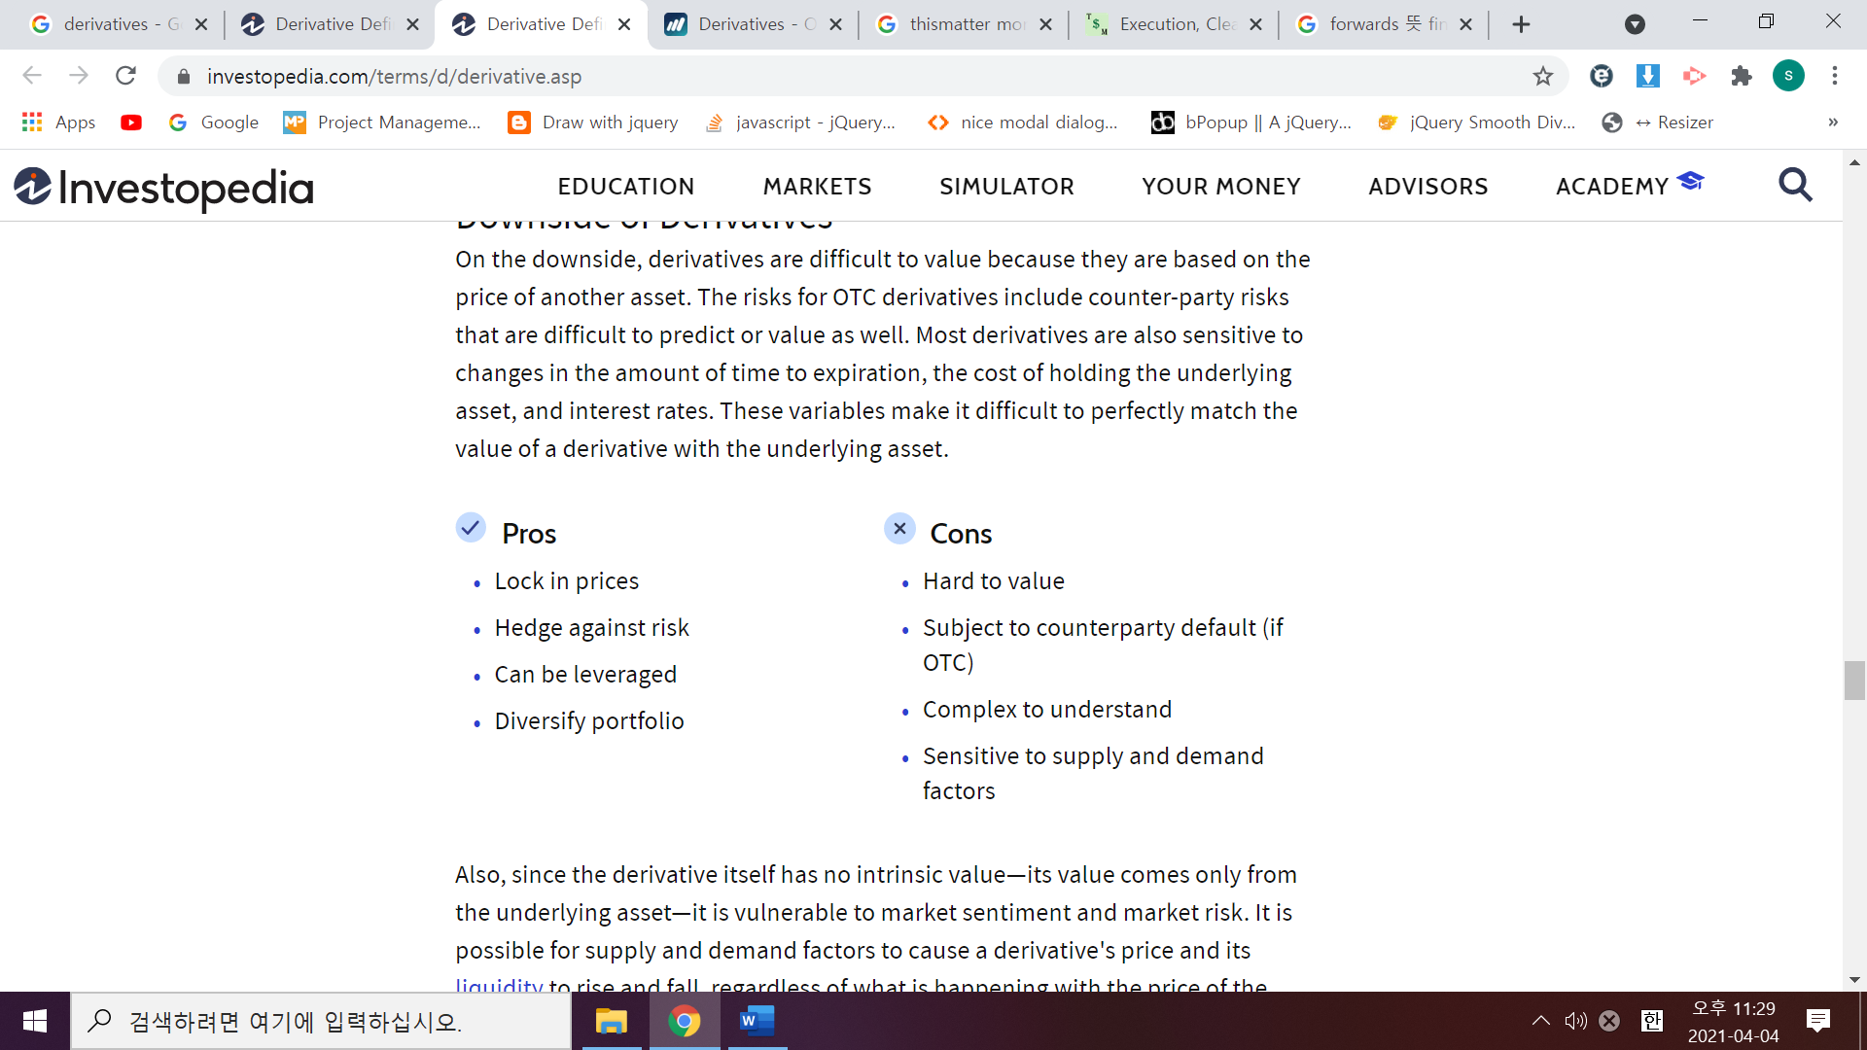

Also, **since the derivative itself has no intrinsic value**—its value comes only from the underlying asset—it is vulnerable to market sentiment and market risk. It is possible for supply and demand factors to cause a derivative's price and its liquidity to rise and fall, regardless of what is happening with the price of the underlying asset.

Finally, derivatives are usually leveraged instruments, and using leverage cuts both ways. While it can increase the rate of return it also makes losses mount more quickly.

# Appendix

<https://thismatter.com/money/stocks/settlement-and-clearing.htm>